Subject: UW Bothell Carryover Allocation Process
Date: November 14, 2018
Purpose: The following document outlines the methodology for UW Bothell’s institutional carryover allocation, effective FY 2019. This policy applies only to UW Bothell’s state operating budget (i.e. General Operating Fund, Designated Operating Fund and Research Cost Recovery) and does not apply to any other funding sources.
Carryover Allocation
Effective FY 2019, UWB will institute a biennial institutional carryover policy on unused funds (henceforth referred to as carryover) in state operating budgets. In support of RCM adoption, UW Bothell will have separate allocation policies for academic and non-academic units (see Example 1).
Academic Unit Policy
An academic unit is defined as a school or the First Year & Pre-Major Program (FYPP) of UW Bothell.
- 85% of carryover funds will be returned to the Vice Chancellor of Academic Affairs, for utilization and allocation
- 15% of carryover funds will be retained by the institution
Non-Academic Unit Policy
A non-academic unit is defined as a unit of UW Bothell that is not defined as a school or FYPP.
- 70% of carryover funds will be returned to the unit’s divisional leadership
- 30% of carryover funds will be retained by the institution

Exemptions
The following are the only exemptions to the carryover allocation policy. Funds in these budgets will be returned directly to the appropriate budget owner. Additional one-time or perpetual exemptions can be made at the approval of the Chancellor (see Example 1).
- University steward budgets
- Encumbered faculty startup commitments- Exemption is limited to contractually committed startup packages as part of a new hire package, retention offer, or additional university commitment.
- Research Cost Recovery (RCR) funds- Includes activity within schools and centers RCR (75-) budgets and RCR allocated to the UW Bothell Office of Research

Institutional Allocation
Carryover funds retained by the university will be allocated in the following manner, providing funding to each university resource in full, as required, until the funds are exhausted.
- Campus Reserve funded to 10% of UW Bothell’s state operating budget.
- Central UW Bothell costs to include, but not limited to, utilities, building operations and maintenance, real estate leases, and UW Seattle overhead for the biennium.
- UW Bothell Investment Fund
- Supplementary capital, asset and equity funds
Deficits
Academic Units
The deficit resolution policy will take effect for any academic unit that ends a biennium with a deficit on their state operating budgets. For the purposes of divisional carryover allocation, central UW Bothell, not the Vice Chancellor of Academic Affairs, will initially fund the deficit for budget balancing with the University of Washington and the academic unit will enter into the deficit resolution policy with the institution of UW Bothell (see Example 2).
Non-Academic Units
The deficit resolution policy will take effect for any non-academic unit that ends a biennium with a deficit on their state operating budgets. For the purposes of division carryover allocation, the unit’s divisional leadership will fund the deficit with carryover from other non-academic units in its division.
For example, if a division has two non-academic units, and Unit A produces a positive carryover balance of $300,000 and Unit B produces a negative carryover balance of $200,000, the net carryover balance is $100,000. Per the policy, 30%, or $30,000 will be retained by the institution, while $70,000 is returned to divisional leadership (see Example 3).
Changes to Policy
The Chancellor of UW Bothell retains decision-making authority connected to all matters and areas related to this policy.

Example 1: Carryover Allocation Process
 | Academic Unit | Non-Academic Unit | Steward Budget
Carryover Amount | $250,000 | $250,000 | $250,000
less, Faculty Startup | $50,000 | $0 | $0
less, Steward Budget Exemption | $0 | $0 | $250,000
Carryover Base | $200,000 | $250,000 | $0
Allocation Retained (%) | 85% | 70% | N/A
Carryover Retained by Division | $220,000 | $175,000 | $250,000
Faculty Startup | $50,000 | $0 | $0
Carryover | $170,000 | $175,000 | $250,000
Carryover Retained by UW Bothell | $30,000 | $75,000 | $0

Example 2: Academic Unit Carryover Allocation
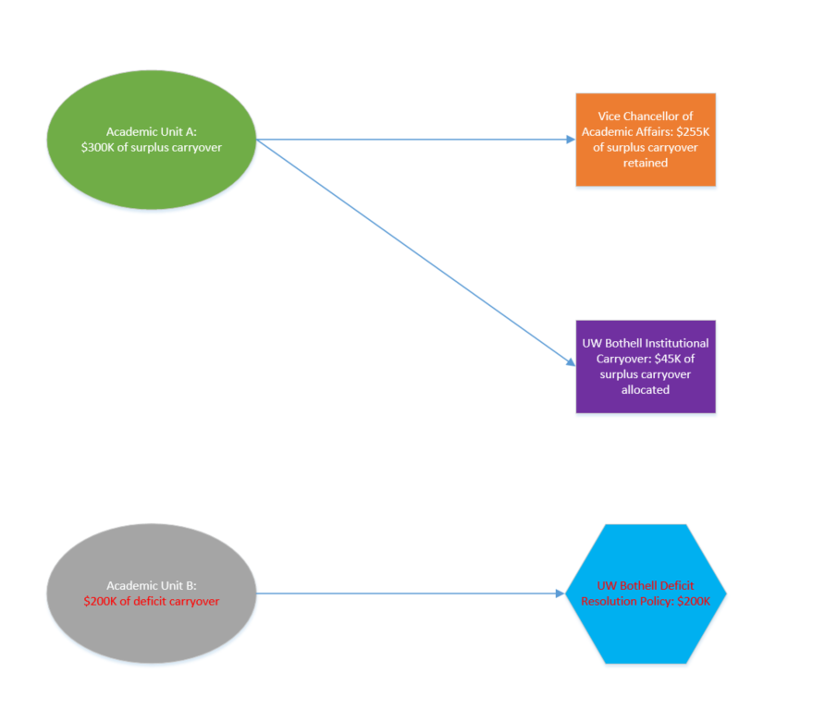

Example 3: Non-Academic Unit Carryover Allocation
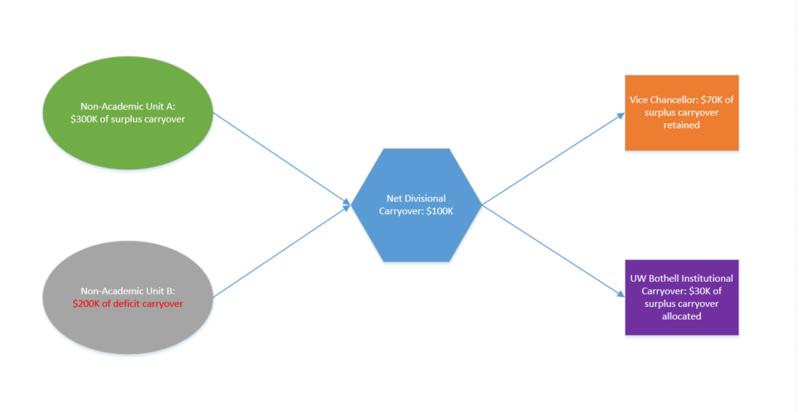
Frequently Asked Questions (FAQs)
- Why are funds being allocated to the division’s leadership instead of directly back to the unit?
Prior to this policy, the practice at UW Bothell had been to allocate carryover funds not retained by the university back to divisional leadership (i.e. Chancellor and Vice Chancellors). This policy formally adopts that practice and gives authority to divisional leadership to allocate and utilize their carryover funds at their discretion.
- If central budgets (e.g. campus reserve, overhead tax, utilities, real estate) produce carryover funds, are those carryover balances subject to the non-academic unit carryover policy?
No, central budgets are not subject to the non-academic unit carryover policy. Carryover funds in the campus reserve are returned directly to the campus reserve fund. All other carryover funds from central funds are returned to the overall central funds pool to support the expenditures of those budgets.

- Why do academic and non-academic units have separate policies?
Under an RCM budget model, academic units are expected to be financially self-sustaining in ways that non-academic units are not. In support of this responsibility, academic units will retain a larger portion of their carryover funds.

- What is a university steward budget?
A steward budget is a budget operated by a local unit on behalf of the university that covers institutional operational expenditures. Two examples of steward budgets at UW Bothell are the Equipment Replacement budget in Information Technology and the Collections budget in Library Services.
- Why are RCR funds exempt from this policy?
Research Cost Recovery (RCR) funds are resources retained by the University Washington that are expected to support expenditures associated with the support and administration of research and other sponsored activity at the university. Carryover funds retained by the university may not go directly to support those efforts.

- What happens if there is not enough carryover retained to fill all of the university resources?
Carryover funds will be allocated to the university resources listed above, in the order listed above, to their full required level. For example, all carryover funds will be allocated to the campus reserve until the reserve reaches 10% of UWB’s annual state operating budget. If retained carryover funds are available after filling the campus reserve, those funds will be allocated to cover central UW Bothell costs. Funds will be allocated in this way until the carryover funds are exhausted. For example, if the goal of the Investment Fund is to have $2.5M available, and only $0.5M of carryover funds are available after funding the campus reserve and central UWB costs, the Investment Fund will be allocated the remaining $0.5M carryover funds and other funding sources will need to be identified to fully fund the Investment Fund.

Policy Document Timeline:
October 18, 2018
- Institutional Planning & Budget (IPB) drafts initial recommendation
- IPB solicits feedback from campus leadership
November 14, 2018
- IPB submits policy recommendation to Chancellor
January 4, 2019
- Chancellor approves Policy

