CAMPUS DESIGN REVIEW TEAM EVALUATION

*FINAL TEMPLATE*

|  |
| --- |
| Template: Cdrt project title – recomMendations & report |
|  |
| [Type the abstract of the document here. The abstract is typically a short summary of the contents of the document. Type the abstract of the document here. The abstract is typically a short summary of the contents of the document.] |

|  |
| --- |
|  |
|  |
|  |



**Campus Design Review Team Recommendations and Report**

**Table of Contents**

1. Project Background and Location 2
2. Risk(s) 3
3. General Criteria Review 3
4. Design Principles Review Comments 4
5. Report Appendix 5



*FINAL TEMPLATE*

**A. Project Background and Location**

[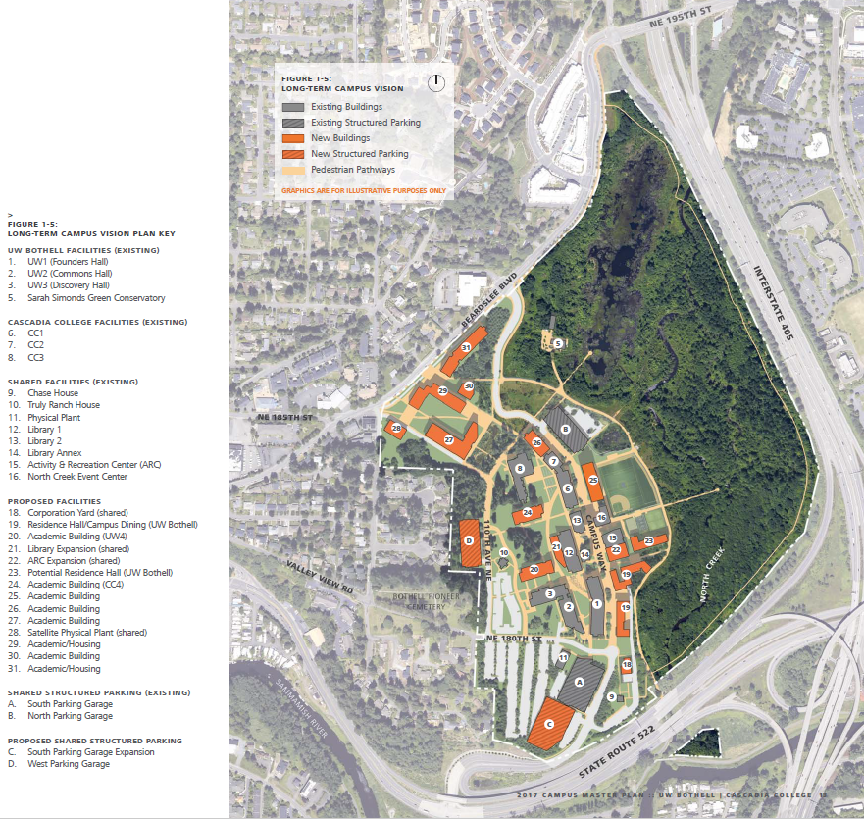](https://www.uwb.edu/getattachment/campusplanning/master-plan/2017-12-13-CMP-FINAL-spreads.pdf)

**1. Brief Description:**

Include here a brief description of what the project is and why it falls within the purview of the Campus Design Review Team referencing one or more of the CDRT purposes within the Appendix Section 02.

PROJECT LOCATION

DESCRIPTION HERE

**2. Application to Campus Design Review:**

Include here all of the potential impacts on the **campus setting,** for this project, including any historic resources:

* campus landscape,
* plantings,
* circulation corridors and gathering places,
* building exteriors,
* public spaces and rights of way,
* signage, and /or
* shared building interior public spaces.

**3. Location:**

Include here a brief description of the project’s location within campus noting the current context (i.e., “to the south is _____and to the east is ____” ) as well as the future context identified in the long-range Master Plan. Edit the text box green text to identify the general location on campus. Click on the text box then click on the yellow arrow leader line in order to change the arrow’s pointing orientation.

**4. Area of Project:**

Include the approximate dimensional size and height of the proposed project, as applicable.

**5. Time and Duration:**

Include the approximate timeframe for the design and implementation of the project. Include the expected completion date.

*IN-PROGRESS EARLY DRAFT*

**B. Project Risk(s)**

Include general image(s) of the Project, if applicable.

Include here a brief lists of observations and CDRT matters of consideration specific for this project. Then identify some risks to the campus if this project is not pursued.

**C. General Criteria Review**

1. Does this project have the potential to impact the COHESIVE CAMPUS CHARACTER? If so, in what way?
2. Does this project impact the DURABLE AND ADAPTABLE FACILITIES of the Campus? If so, in what way?
3. Does this project have the potential to ENRICH the CAMPUS COMMUNITY EXPERIENCE? If so, in what way?
4. Does this project have the potential to ENHANCE the CAMPUS ENVIRONMENTAL & HUMAN HEALTH? If so, in what way?
5. Does this project involve INTEGRATION WITH THE CITY OF BOTHELL? If so, in what way(s)?

1. Does this project have the potential to impact the MOBILITY, ACCESS, AND SAFETY on Campus? If so, in what way(s)?



**D. Design Principles Review Comments**

DESIGN PRINCIPLES:

(Refer to appendix; CIRCLE ALL THAT APPLY)

DP11- TOPOGRAPHY

DP12- OPEN SPACE & VIEW CORRIDOR

DP13- VEGETATION & LANDSCAPE

DP14- WETLANDS

DP15- TREE CANOPY

DP16- HYDROLOGY

DP17- GEOTECHNICAL CONSIDERATION

DP21- SNUGNESS

DP22- BUILDING MODULATION & SCALE

DP23- ROOF DESIGN & MECH. SCREEN

DP24- COMPLEMENTARY MATERIALS

DP25- ENHANCED PUBLIC REALM

DP26- ACTIVE FAÇADES

DP31- DURABILITY & MAINTAINABILITY

DP32- RESOURCE CONSERVATION & HEALTHY MATERIALS

DP33- SUSTAINABILITY / LEED CERTIF.

DP41- PRIORITZE PEDESTRIAN EXPERIENCE

DP42- IMPROVED BICYCLE CONNECTIONS

DP43- IMPROVED BICYCLE STORAGE

DP44- WELL-INTEGRATED VEHICULAR CIRCULATION

DP51- STORMWATER

DP52- SANITARY SEWER

DP53- DOMESTIC WATER

DP54- NATURAL GAS

DP55- CHILLED WATER

DP56- POWER

DP57- TELECOMMUNICATIONS & DATA

Mark in the right margin by circling all of the Master Plan Design Principles that the Campus Design Review Team must consider. Then, provide your comments below including the “DP#.n”:

1. [DP ___.__]
2. [DP ___.__]
3. [DP ___.__]
4. [DP ___.__]
5. [DP ___.__]

**D. Design Principles Review Comments (continued)**

1. [DP ___.__]
2. [DP ___.__]
3. [DP ___.__]
4. [DP ___.__]
5. [DP ___.__]

|  |  |  |  |
| --- | --- | --- | --- |
| **CAMPUS MASTER PLAN DESIGN PRINCIPLES:** | **PROJECT(s):** (Check all that apply) | | |
| (Refer to Appendix of CDRT Recommendations & Report) | **YY-01**  **Name 1** | **YY-02**  **Name 2** | **YY-03**  **Name 3** |
| DP11- TOPOGRAPHY |  |  |  |
| DP12- OPEN SPACE & VIEW CORRIDOR |  |  |  |
| DP13- VEGETATION & LANDSCAPE |  |  |  |
| DP14- WETLANDS |  |  |  |
| DP15- TREE CANOPY |  |  |  |
| DP16- HYDROLOGY |  |  |  |
| DP17- GEOTECHNICAL CONSIDERATION |  |  |  |
| DP21- SNUGNESS |  |  |  |
| DP22- BUILDING MODULATION & SCALE |  |  |  |
| DP23- ROOF DESIGN & MECH. SCREEN |  |  |  |
| DP24- COMPLEMENTARY MATERIALS |  |  |  |
| DP25- ENHANCED PUBLIC REALM |  |  |  |
| DP26- ACTIVE FAÇADES |  |  |  |
| DP31- DURABILITY & MAINTAINABILITY |  |  |  |
| DP32- RESOURCE CONSERVATION & HEALTHY MATERIALS |  |  |  |
| DP33- SUSTAINABILITY / LEED CERTIF. |  |  |  |
| DP41- PRIORITZE PEDESTRIAN EXPERIENCE |  |  |  |
| DP42- IMPROVED BICYCLE CONNECTIONS |  |  |  |
| DP43- IMPROVED BICYCLE STORAGE |  |  |  |
| DP44- WELL-INTEGRATED VEHICULAR CIRCULATION |  |  |  |
| DP51- STORMWATER |  |  |  |
| DP52- SANITARY SEWER |  |  |  |
| DP53- DOMESTIC WATER |  |  |  |
| DP54- NATURAL GAS |  |  |  |
| DP55- CHILLED WATER |  |  |  |
| DP56- POWER |  |  |  |
| DP57- TELECOMMUNICATIONS & DATA |  |  |  |
| *NUMBER OF APPLICABLE PRINCIPLES* |  |  |  |