Earnings and Actuals Tips
Use this guide to review Earnings and Actuals in Workday.

Earnings and Actuals Options:
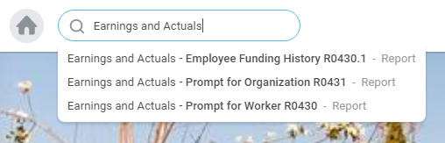

Earnings and Actuals by Employee:

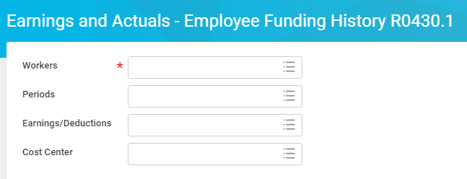

Earnings and Actuals by your Organization (Sup Org) R0431:

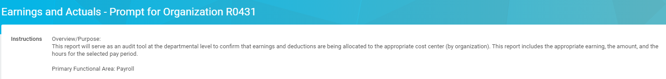

You can have more than one Sup Org – for this example we’re selecting JM Student:

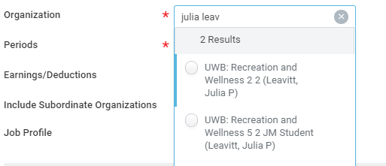

For this example we’re selecting “Last Periods Completed”:

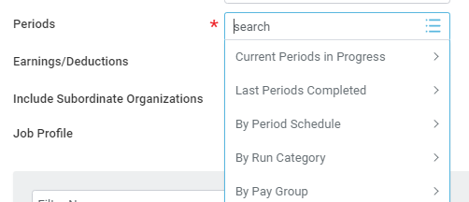

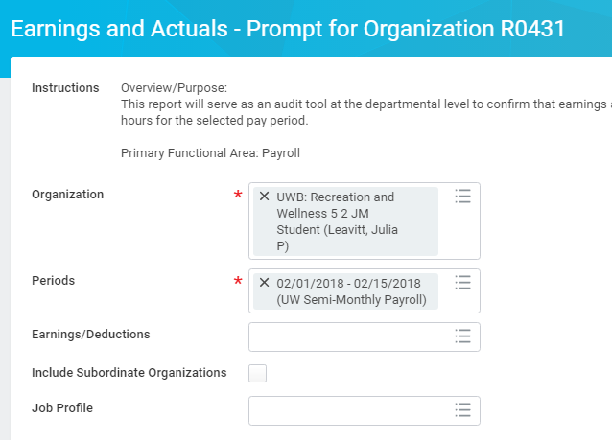

Hit “OK”

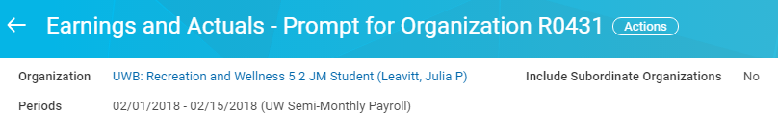

You’ll be able to see the Workers, Hours, Cost Center, PN, and Amount on this report. Actual report results Not displayed here.

You can also export it into Excel from the upper right hand corner of the Workday report to save it or filter and play as needed:

As well as:
