Accessing EXPO
- To access EXPO, you can use this link: http://expo.uw.edu/expo/service_learning OR visit the Community-Based Learning and Research website (highlighted in red):
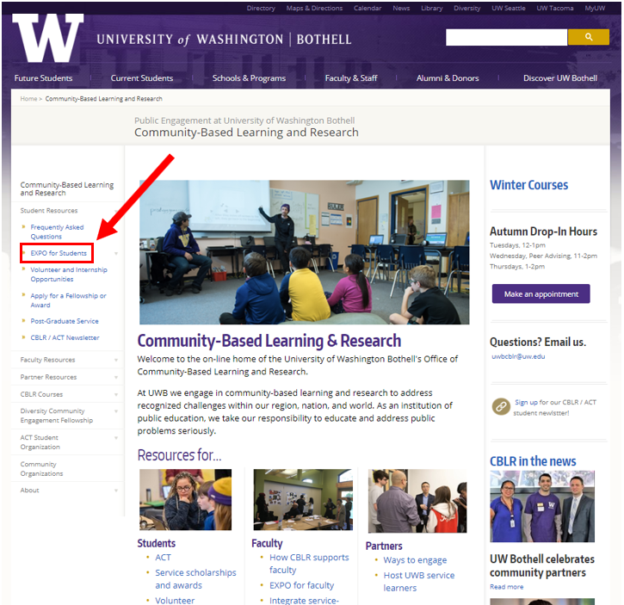
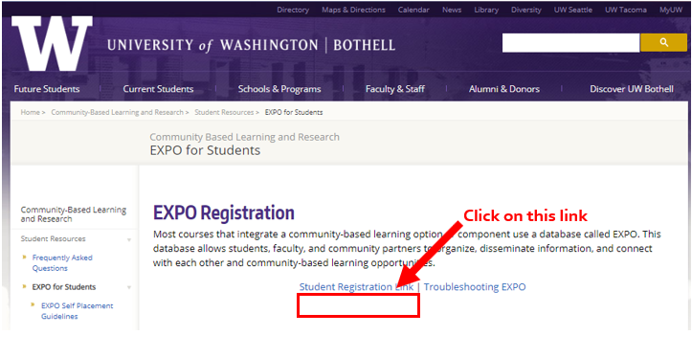

- Once you click on the “Student Registration Link”, you will be directed to the page below. Click the “Sign In” button:
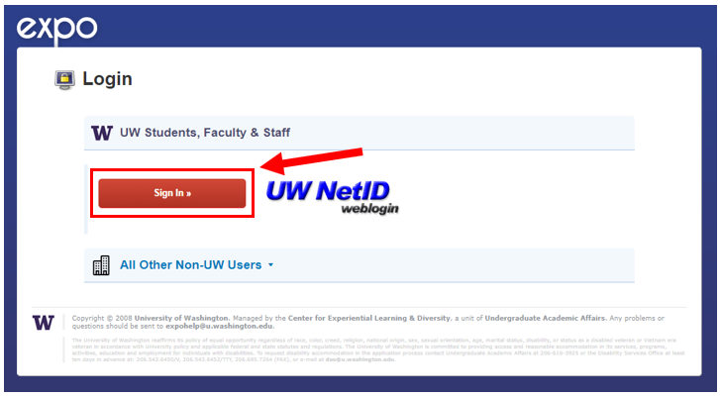

- You will then be prompted to log in using your UW Net ID.
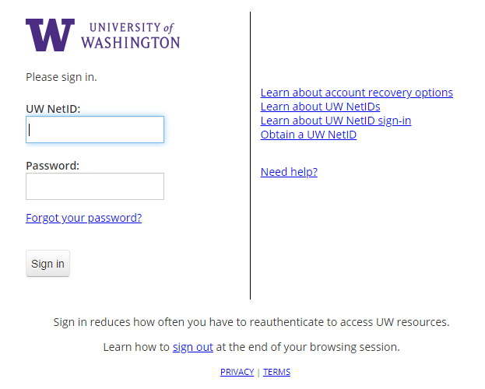

- If you are enrolled in a CBLR course, you will see a page similar to the one below once you log in:
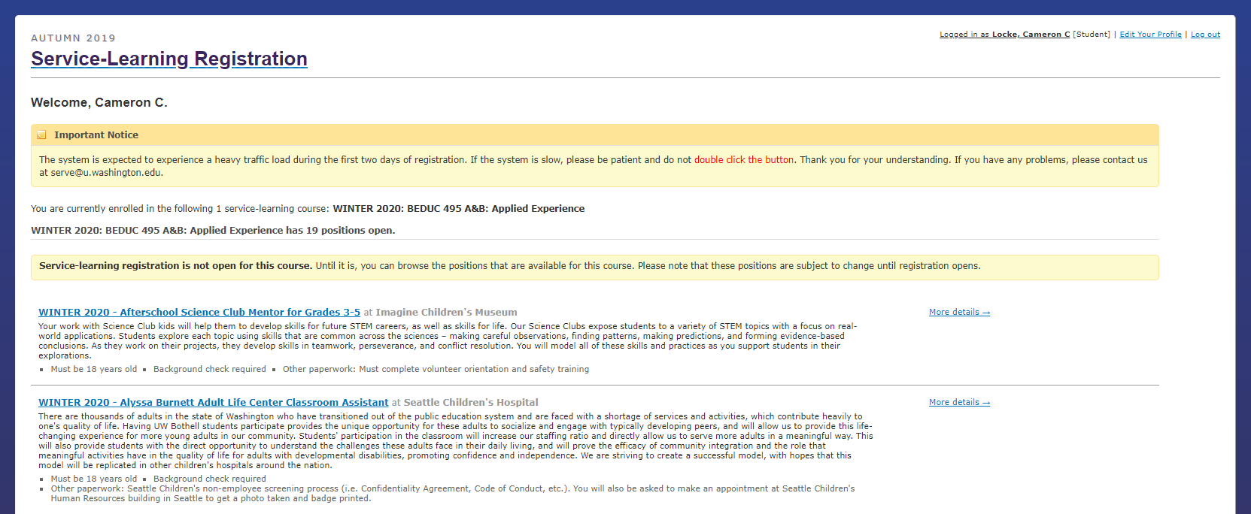
Viewing and Registering for a Position
- You will be able to view position descriptions on the page shown above. If you want to know more about a position you are interested in, click on the position title (highlighted in red). NOTE: You will only be able to view positions until the Office of CBLR opens EXPO for registration.
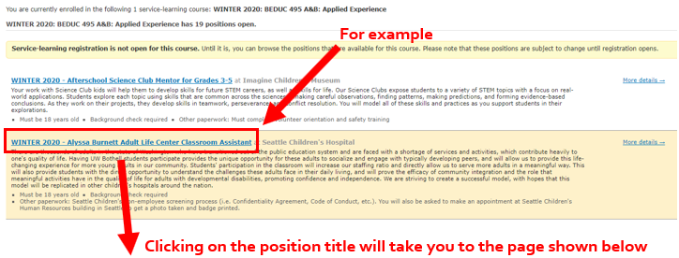
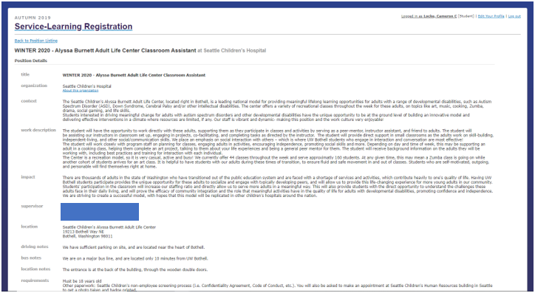
Please note: the above screenshot is a snippet of the full position description. Be sure you scroll through and read the entire position description to ensure that it is a good fit for you!

- If you are interested in a position and EXPO is open for registration, you will see the following on the home page for your CBLR course’s positions in EXPO:
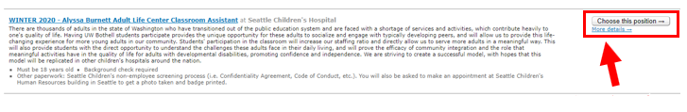
Click on the “Choose this position ” button.

- You will be directed to the page below. Confirm your email and phone number. Hit “Continue”.
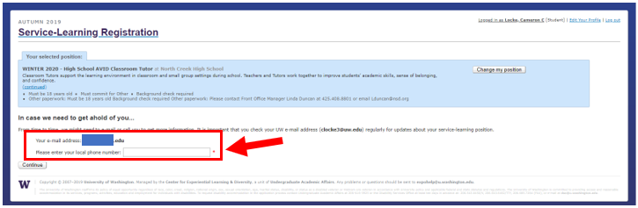
- Read through the information, then sign your name in the box to acknowledge that you’ve read through the information (highlighted in red). Hit “Finish my Registration” to confirm your position. You will then be taken to a page with next steps. Please read and follow the steps carefully to ensure you know what your next steps are.
