How to Add a Vehicle to Your Permit
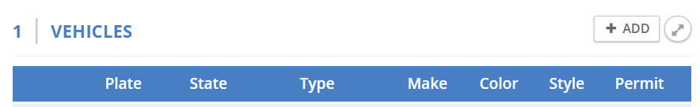
- Step 1: Next to the text saying VEHICLES, click the +ADD button

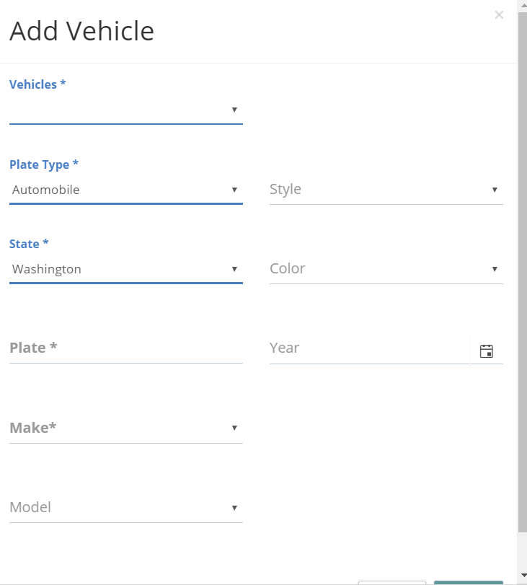
- Step 2: Leave Vehicles* blank, and fill out the rest of the * marked fields (Plate type, State, plate, and make) and click save.
Leave this field blank

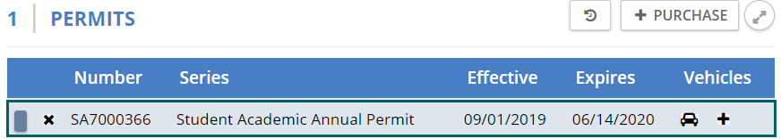
- Step 3: Under permits and the permit you would wish to add your new vehicle to, click on the + icon on the right side.

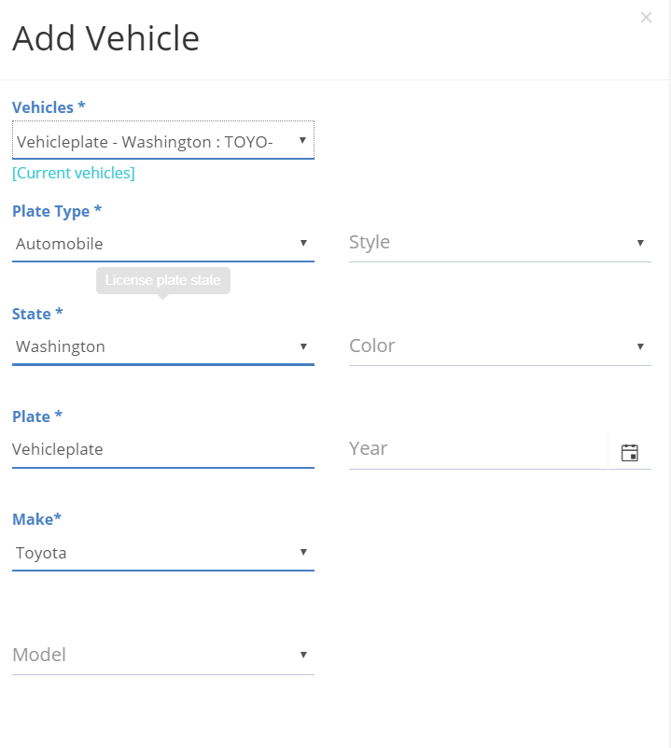

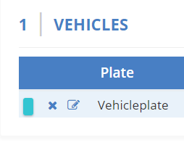
- Step 4: Under Vehicles* select the vehicle that you added, and it will automatically populate the other fields. Click save, and the vehicle should turn blue, meaning it is now associated with a permit.

