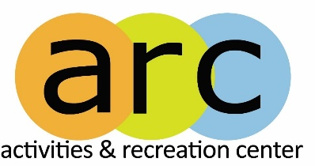
University of Washington Bothell
Intramural Activities
Check-In and Roster Policy
Purpose: To establish a process that ensures all participants are properly rostered and provide appropriate identification when checking in for Intramural Activity events.
Check-In Definition: A check-in is considered complete once a participant has either their student ID or government-issued ID card physically verified by IM staff, and they are signed in based on the printed roster.
Roster Definition: All participants must register within the timelines marketed by Intramural Activities. After the deadline is past, participants may join on an individual basis and be placed on a team. Rosters will be locked 24 hours before every event, meaning if a participant joins afterwards, they will not be on the established roster for the current event. Rosters can be accessed on the IMleagues website.
How it Works: Before every Intramural Activity event, participants must sign in with Intramural Staff to verify they are eligible, fee- paying students from either the University of Washington Bothell or Cascadia Community College. The check-in process will require participants to have their physical school ID on them as well as have their name present on the printed roster. If a student does not have their student ID on them and they have previously checked into events, IM staff will follow the alternative check-in policy.
If a participant is unable to provide a physical copy of either school or government identification, and/or they are not present on the printed roster, they are not eligible to participate in that event.

